

The beautiful crisp morning of 6th September, 2017 saw the charming and cheerful faces of students of JECRC, as they celebrated “GREEN CAMPUS DAY” – an activity under Swachchta Phkwada and motivated everyone with their enthusiasm and zeal to make their campus GREEN.

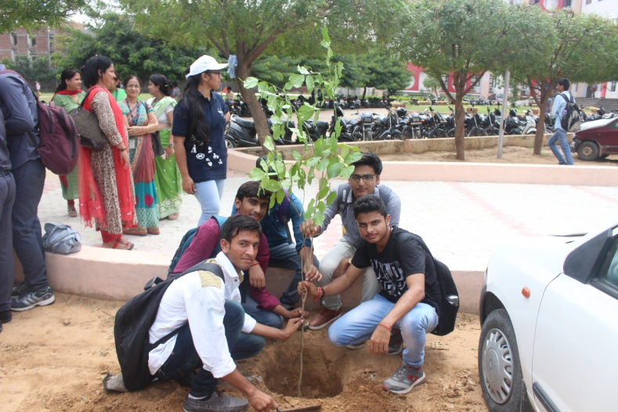 The students of all the Seventeen(17) Sections of First Year planted one tree each outside D block and adopted that plant for next four years.

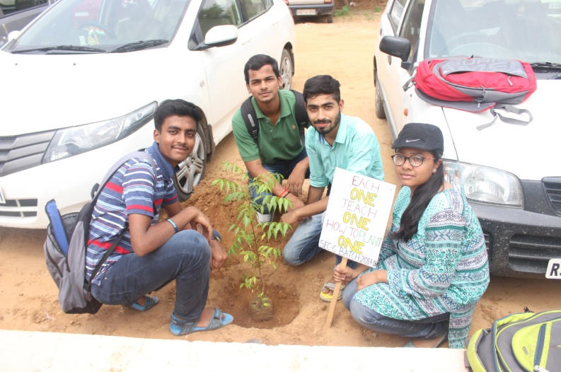

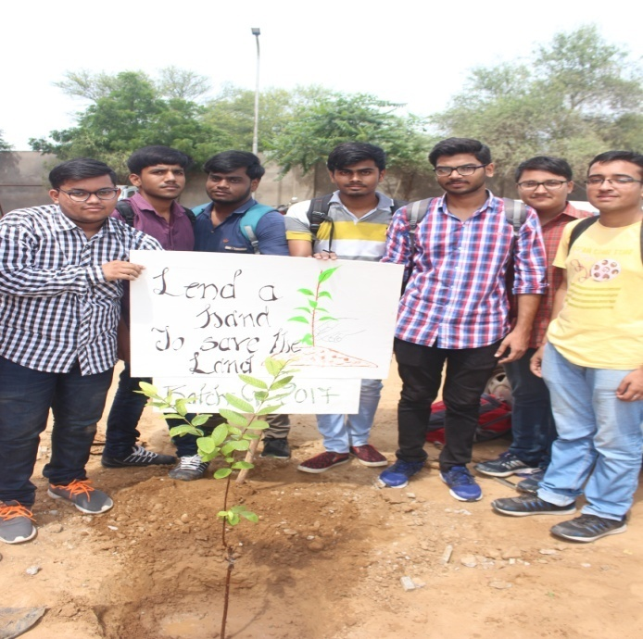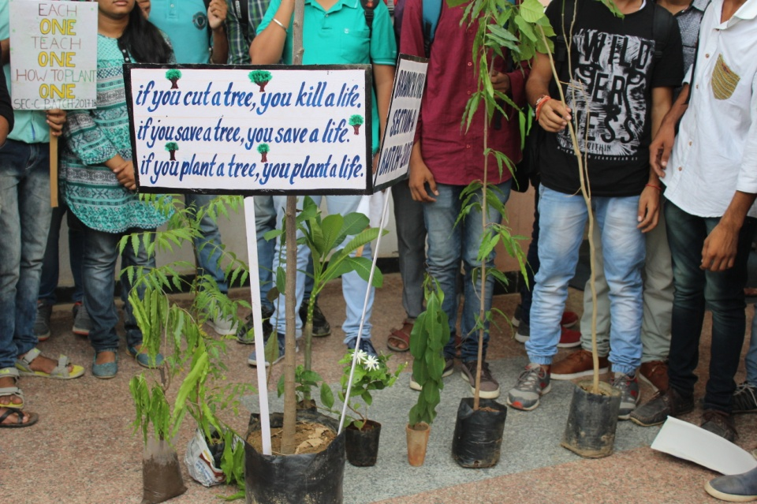 Each Section of First Year also prepared a slogan on Green Environment and displayed it in front of the tree.

Students also organised an interactive session and quiz based on environment and distributed fruits to the participants to promote plantation. One of the students also recited a poem on planting trees written by him.

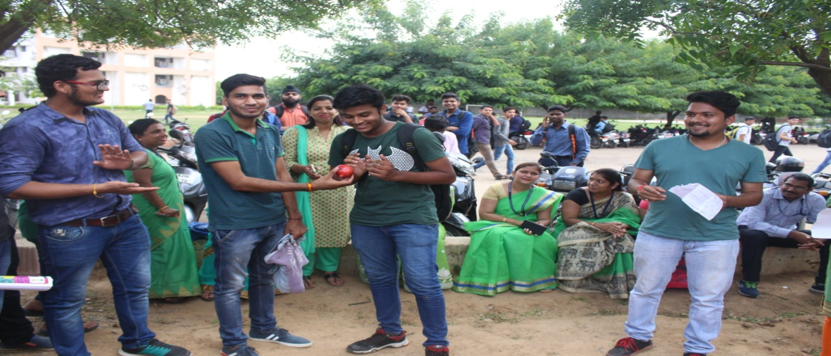

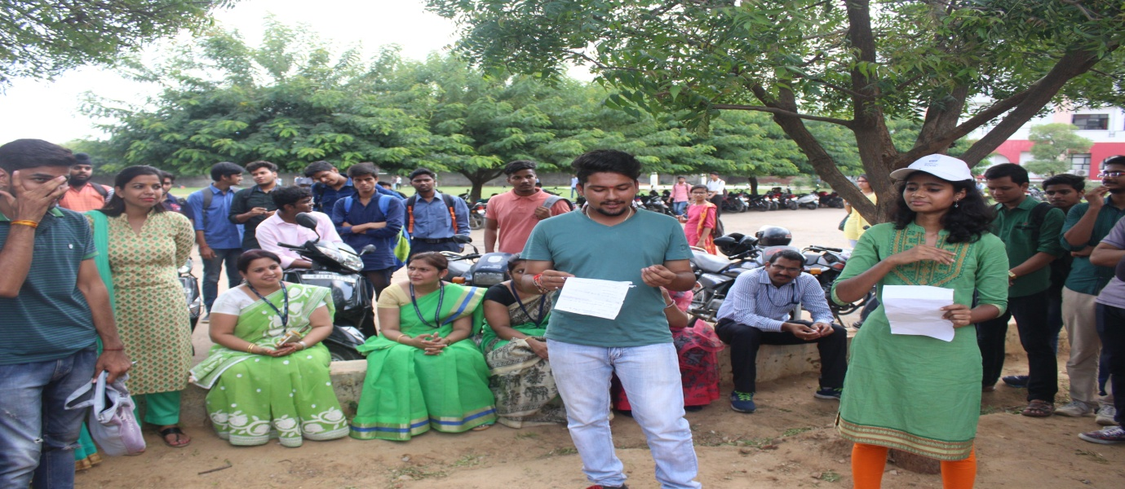

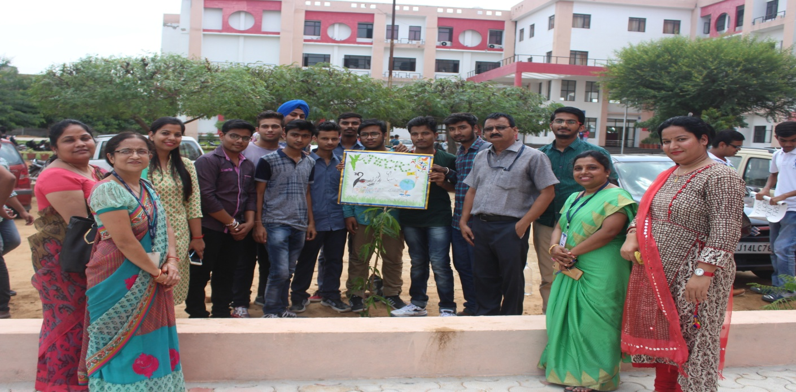

Vice Chairman, Mr. M.L. Sharma, Director Social initiatives, Mr. O.P Jain and Principal JECRC, Prof V.K. Chandana also motivated the students by their presence. They praised the efforts of the students in making their campus Green and Clean. First Year students gifted money plants to the mentors.

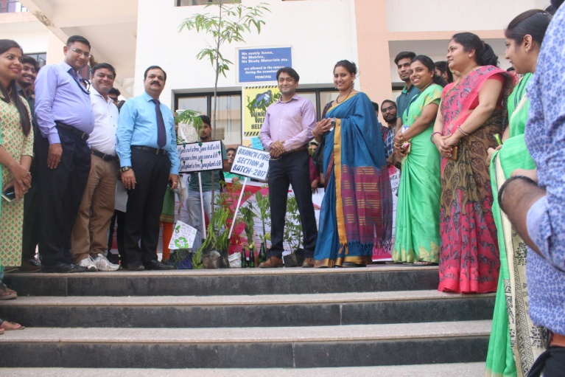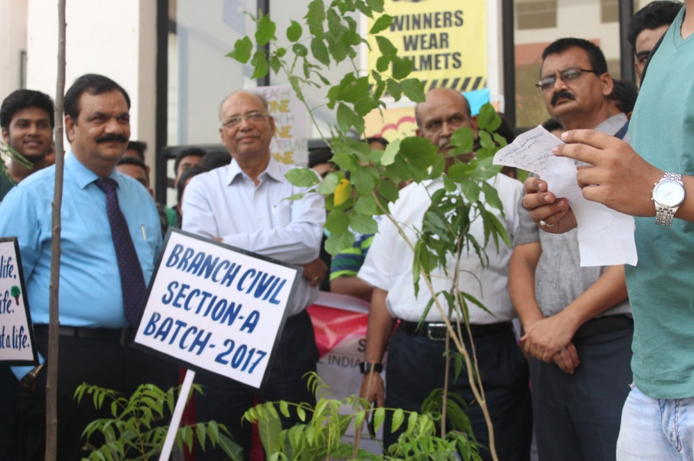

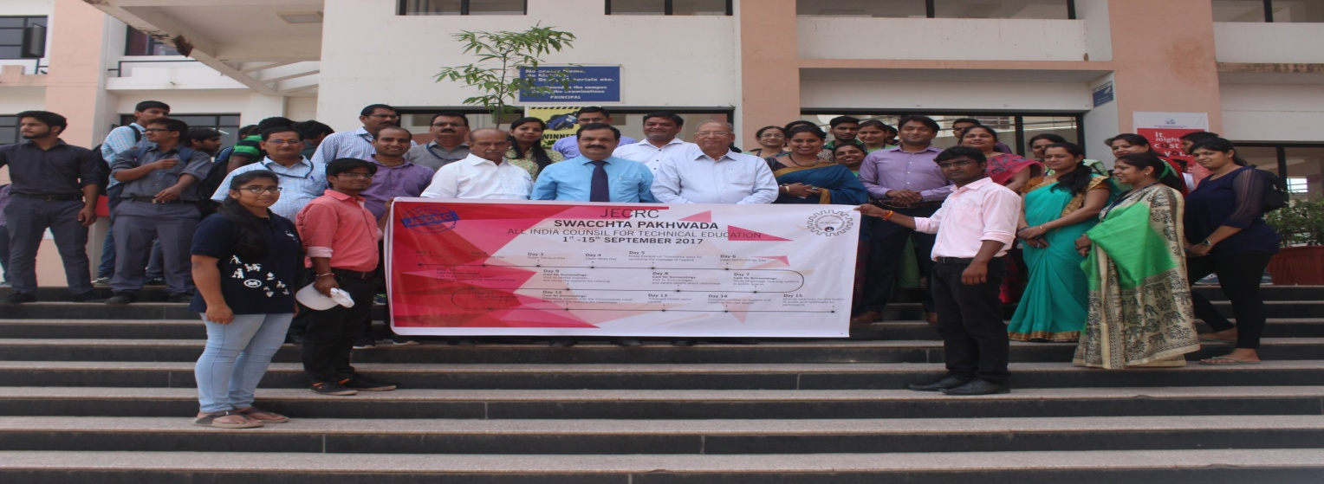

Everyone was spellbound seeing the enthusiasm of the students and it seemed that God has also blessed them by pouring rains on their efforts.

|  |  |  |
| --- | --- | --- |
|  |  |  |
|  |  |  |
|  |  |  |
|  |  |  |